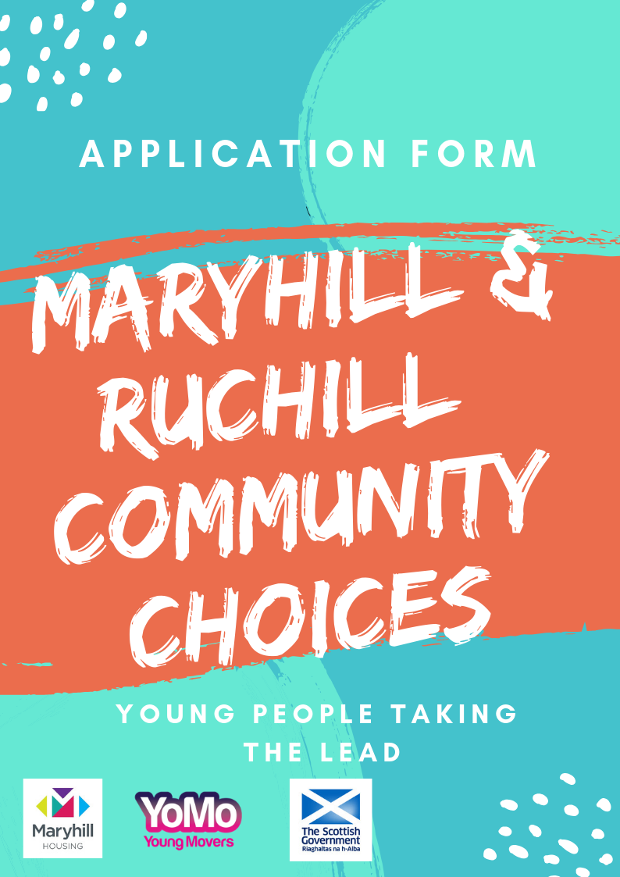

Thanks to funding from the Scottish Government & Maryhill Housing Association young people from Maryhill/Ruchill have been deciding how £40,000 will be spent in their community. Young Movers (YoMo) have been consulting young people on the criteria, priorities and who can get involved in deciding which projects receive funding at our decision making event on Tuesday 19th March 2019.

This approach is known as Participatory Budgeting and it is where local people decide through a voting event how public money will be spent locally. This is different from traditional ways of funding projects where decisions are usually made by a small number of people.

Who can apply
- Any local group can apply for funding for an idea that supports people from Maryhill/Ruchill.

How much is available
- You can apply for between £100 and £5,000
- The total amount of money we have to distribute is £40,000

Where there are more applications than funding available we will shortlist projects that meet one or more of the priorities identified by young people
- Projects that benefit young people

- Projects that promote health and wellbeing

Before you apply
- Please read the application form fully
- If you are unsure if your proposal is suitable for this programme just get in touch and we will advise you

How to apply
- Return this completed application form to caitlin@yomo-online.co.uk
- Application deadline: 3pm Monday 11th March 2019.
- A steering group made up of young people will review the applications received and based on the criteria and priorities listed above will shortlist a number of projects that will put to a public vote at the decision making event
- You will be asked to attend the voting event on Tuesday 19th March 2019 and make your case for funding, through an information stall.
- Members of the community and other applicants will then vote on who gets funded.

YOUR IDEA
Idea name: | Click or tap here to enter text.
Individual/ group/ organisation name: | Click or tap here to enter text.

CONTACT DETAILS
Please provide us with the contact detail of the person we should contact to let them know about the progress of your application.
Name: | Click or tap here to enter text.
Email: | Click or tap here to enter text.
Contact number: | Click or tap here to enter text.

WHAT IS THE IDEA YOU WANT FUNDING FOR?
Let us know what you plan to do. Think about:
- What activities will take place?
- How often will the activity take place and where?
- Describe the people who will get involved (e.g. are they younger or older? Do they have a disability? Are they mostly women?)
- This would be a good place to mention if you meet one of the priorities and how you do so?
Click or tap here to enter text.

WHAT DIFFERENCE WILL YOUR IDEA MAKE TO MARYHILL/RUCHILL?
Let us know what will change because of your idea. Think about:
- What will change for the individual involved? (e.g. they may have learned a new skill, made new friends or be happier)
- What will change for Maryhill/Ruchill (e.g. your idea might increase services for locals, give volunteers the resources and tools they need to improve the area)
Click or tap here to enter text.
PROJECT COSTS
We need to know how much your project will cost, whilst you can apply for up to £5,000 it is important that you only apply for what you need to enable as many ideas to be supported as possible.
Item | Cost
Click or tap here to enter text. | Text.
Click or tap here to enter text. | Text.
Click or tap here to enter text. | Text.
Click or tap here to enter text. | Text.
Click or tap here to enter text. | Text.
Click or tap here to enter text. | Text.
Click or tap here to enter text. | Text.
Click or tap here to enter text. | Text.
TOTAL | Text.

